Sri Lanka Institute of Information Technology



Research Project

IT4010

B.Sc. (Hons) in Information Technology

Status Document - 02

Group ID: 23-139

Registration Number: IT20037338

Full Name: Jayathilake S. M. D. A. R.

Specialization: Software Engineering

**TABLE OF CONTENTS**

1. WORK BREAKDOWN STRUCTURE 3

2. GANTT CHART 4

3. TEAMS PLANNER 5

3.1 TEAMS PLANNER BOARD 5

3.2 TEAMS PLANNER CHART 7

3.3 SCHEDULE 8

4. GIT COMMIT HISTORY 9

4.1 COMMITS 9

4.2 GIT GRAPH 10

5. MEETINGS 11

5.1 MEETINGS WITH THE SUPERVISOR (MR. SAMADHI RATHNAYAKE) 11

5.2 MEETINGS WITH THE CO-SUPERVISOR (MS. DEVANSHI GANEGODA) 13

5.3 MEETINGS WITH THE EXTERNAL SUPERVISOR - PYSCHOLOGIST (MS. AROSHA DASSANAYAKE) 13

5.4 MEETINGS WITH THE EXTERNAL SUPERVISOR – CEO AT XINOTECH (MR. THILANGA JAYARATNE) 14

5.5 MEETINGS WITH THE TEAM 14

6. OTHER ACTIVITIES 16

6.1 NBQSA NATIONAL ICT AWARDS COMPETITION 16

# WORK BREAKDOWN STRUCTURE

The work breakdown structure (WBS) involves breaking down a project or task into smaller, more manageable parts in a hierarchical manner. The WBS plan for our research project outlines the structure and duration of the project, as demonstrated below.

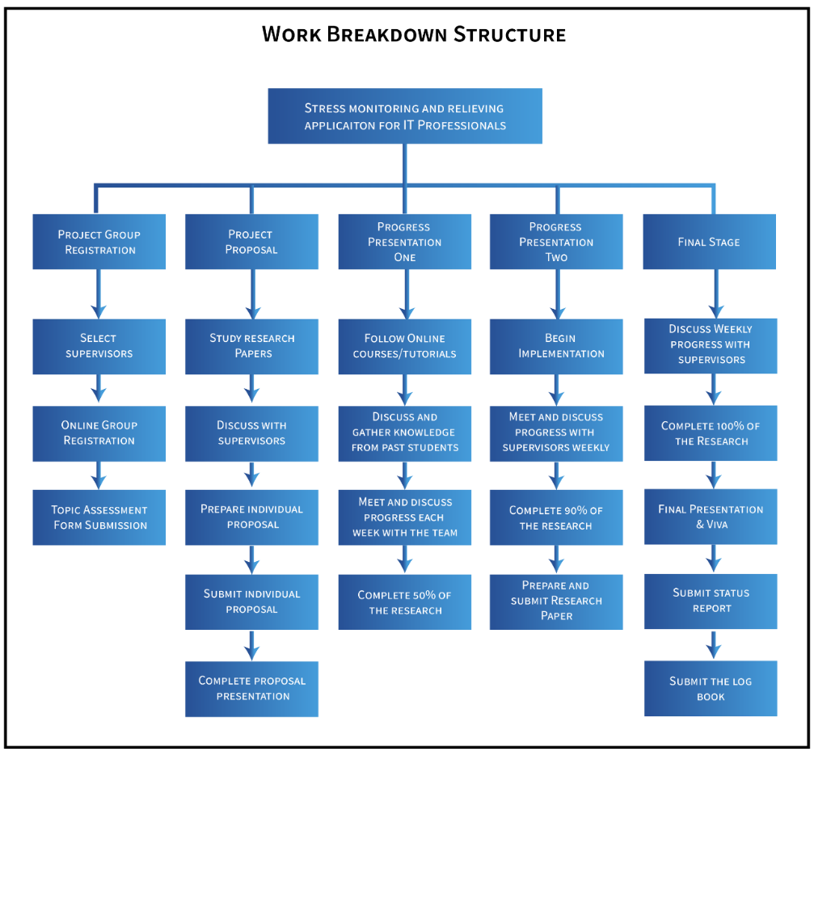

# GANTT CHART

A Gantt chart is a widely used project management tool that provides a visual representation of task schedules and progress over a specific period. The Gantt chart we created to outline our project's timeline is depicted in the diagram below.

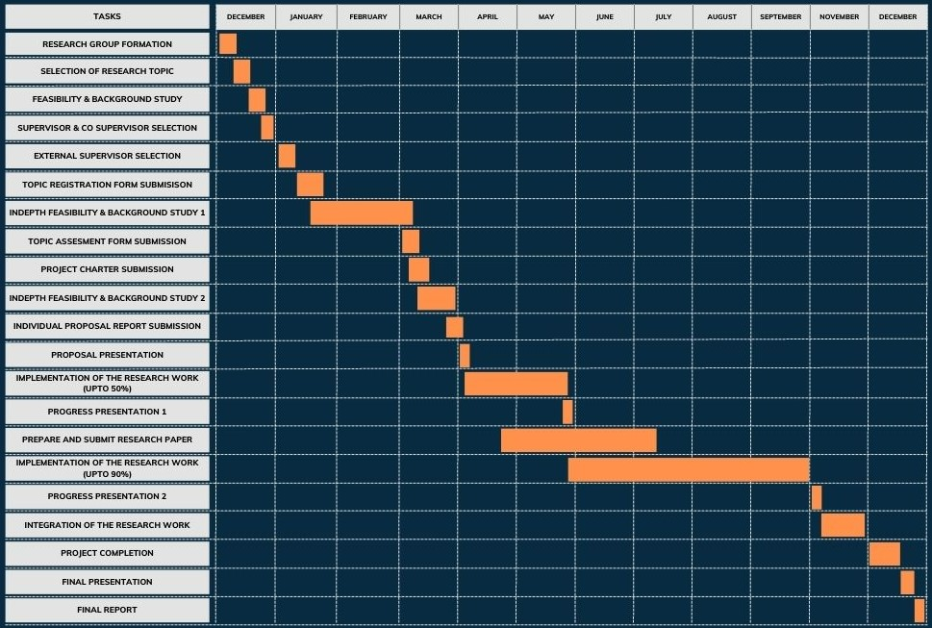

# TEAMS PLANNER

Microsoft Teams Planner is an integrated project management and task tracking tool within the Microsoft Teams collaboration platform. We leveraged this platform to effectively organize, assign, and monitor tasks, facilitating seamless teamwork and efficient project management.

## 3.1 TEAMS PLANNER BOARD

The interface presented below offers a visually appealing representation of tasks utilizing a Kanban board-style layout. This layout provides a user-friendly and intuitive approach to managing and monitoring tasks within a project.

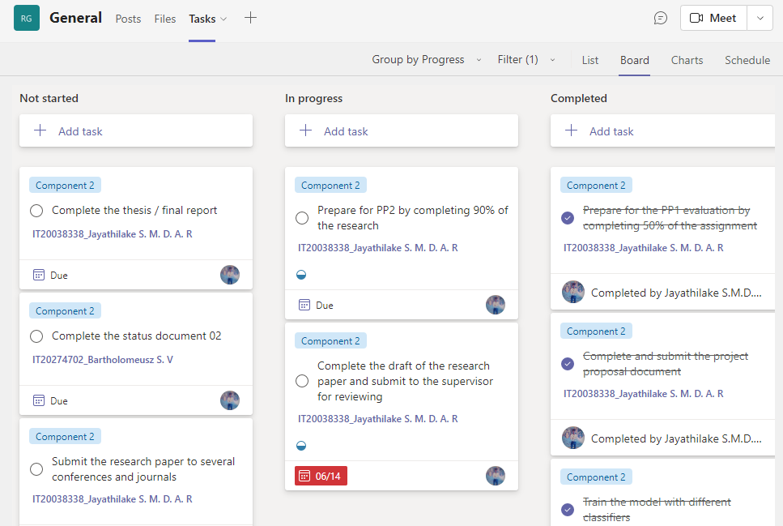

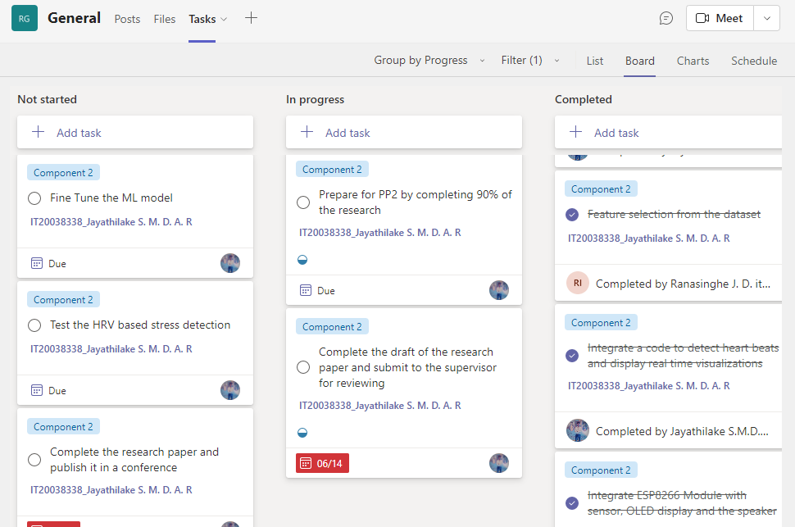

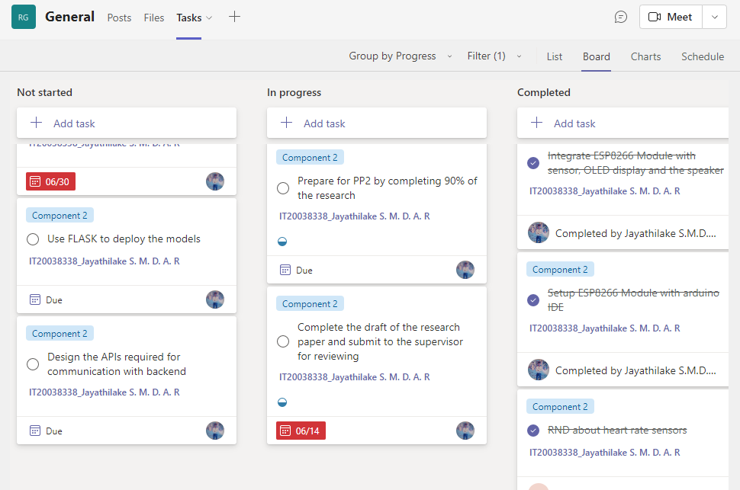

## 3.2 TEAMS PLANNER CHART

The following interface provides a visual representation of tasks using a Kanban board-style layout. It offers a more visual and intuitive way to manage and track tasks within a project.

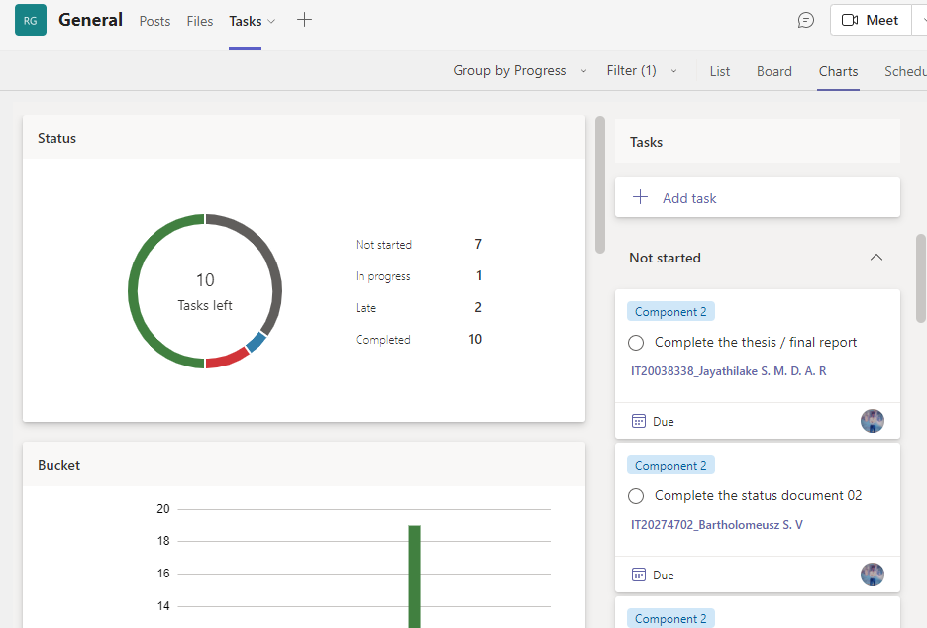

## 3.3 SCHEDULE

Within Microsoft Teams Planner, you have the capability to arrange tasks and define deadlines, enabling the creation of a project timeline or plan. The subsequent calendar provides an outline of some significant dates scheduled for the duration of the research project, offering a comprehensive view of the project's key milestones.

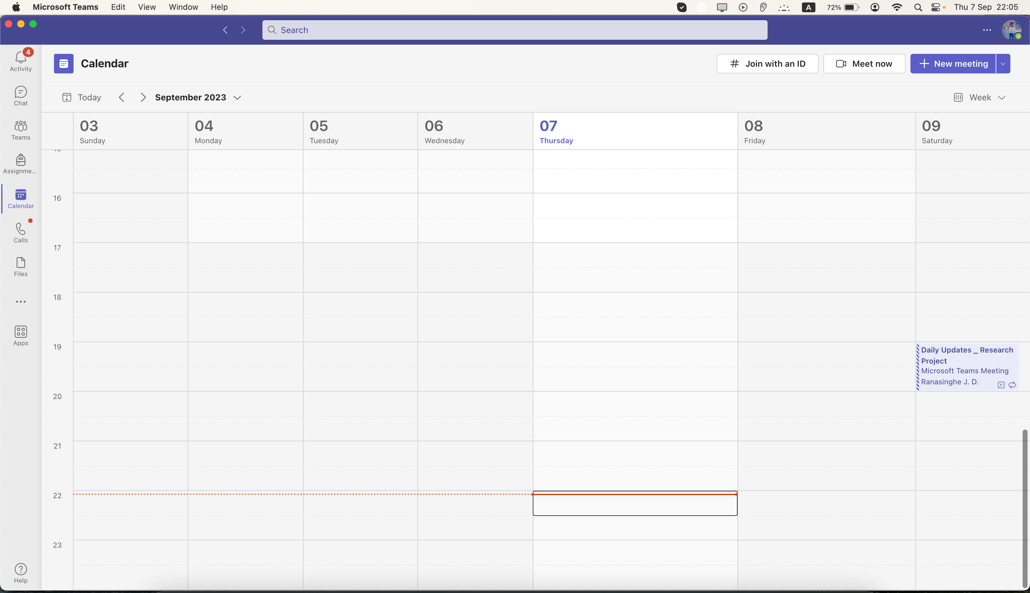

# GIT COMMIT HISTORY

Git commit history refers to the chronological record of commits made to a Git repository. Each commit represents a snapshot of changes made to the files in the repository at a specific point in time.

## 4.1 COMMITS

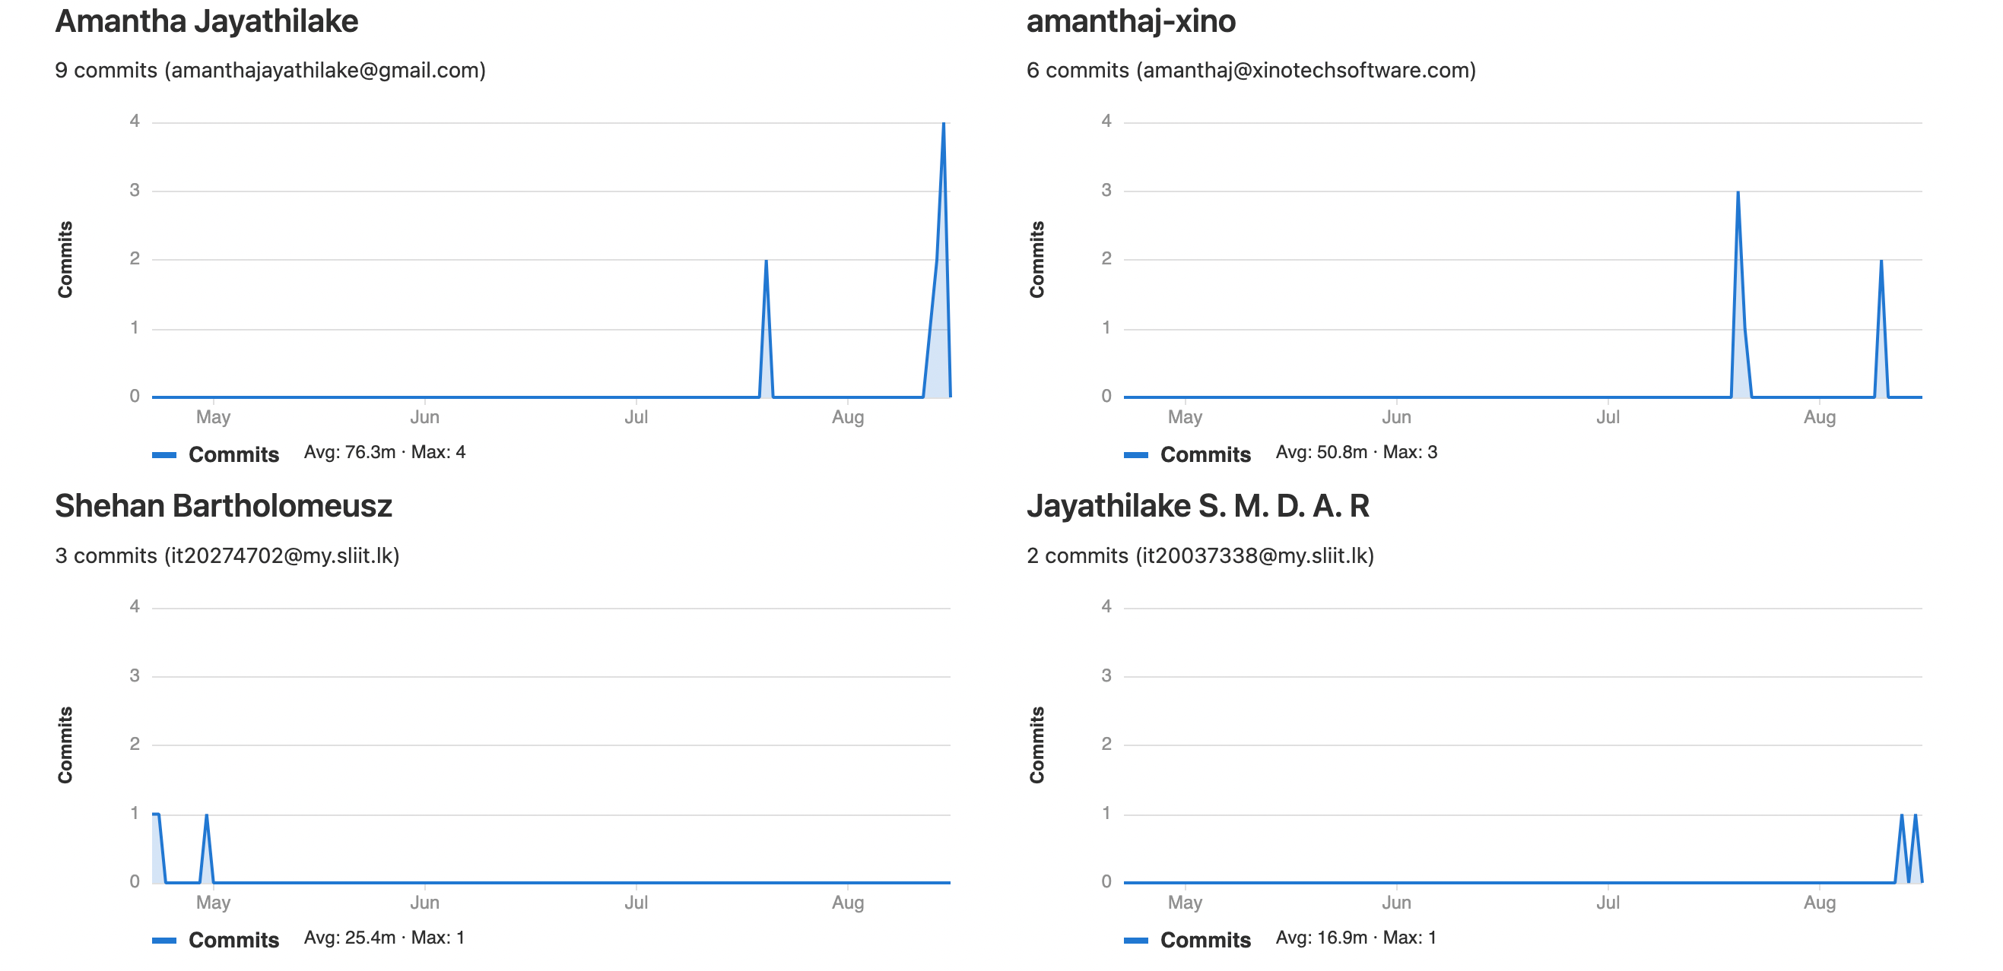

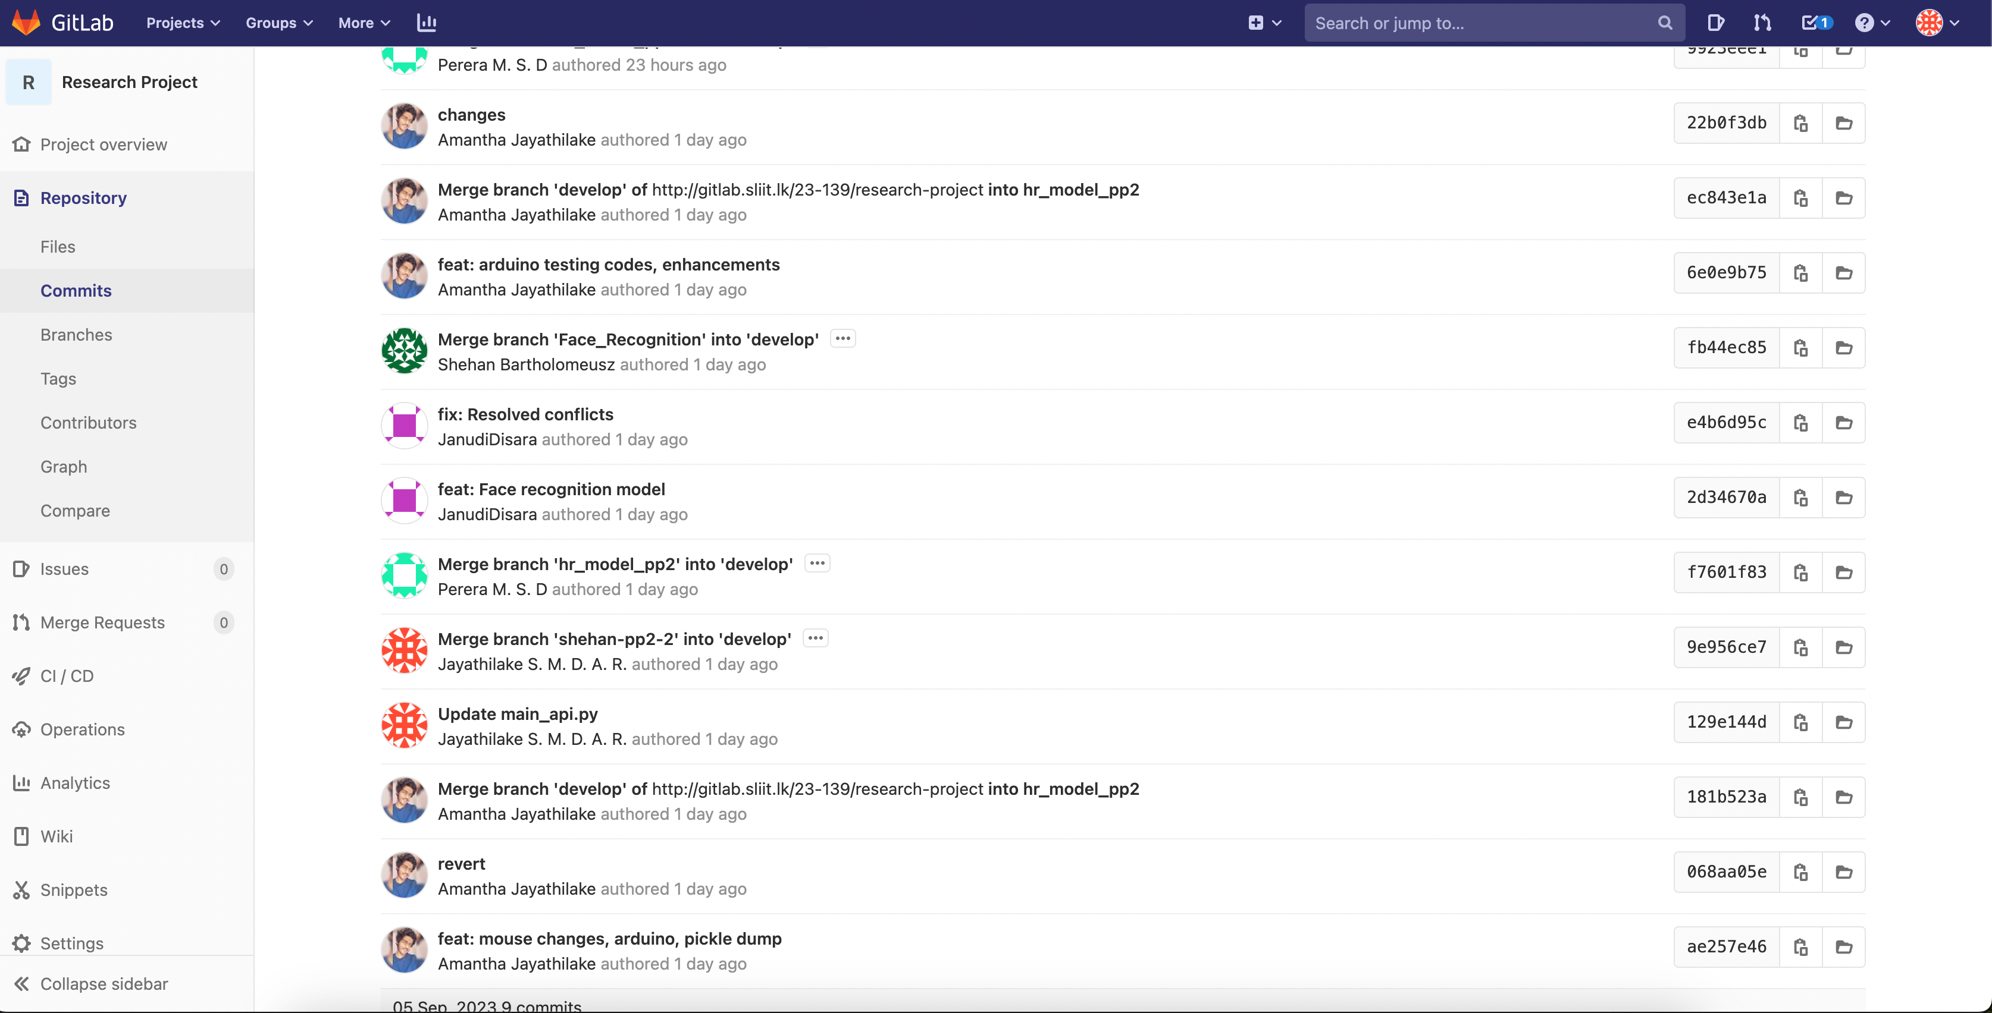

## 4.2 GIT GRAPH

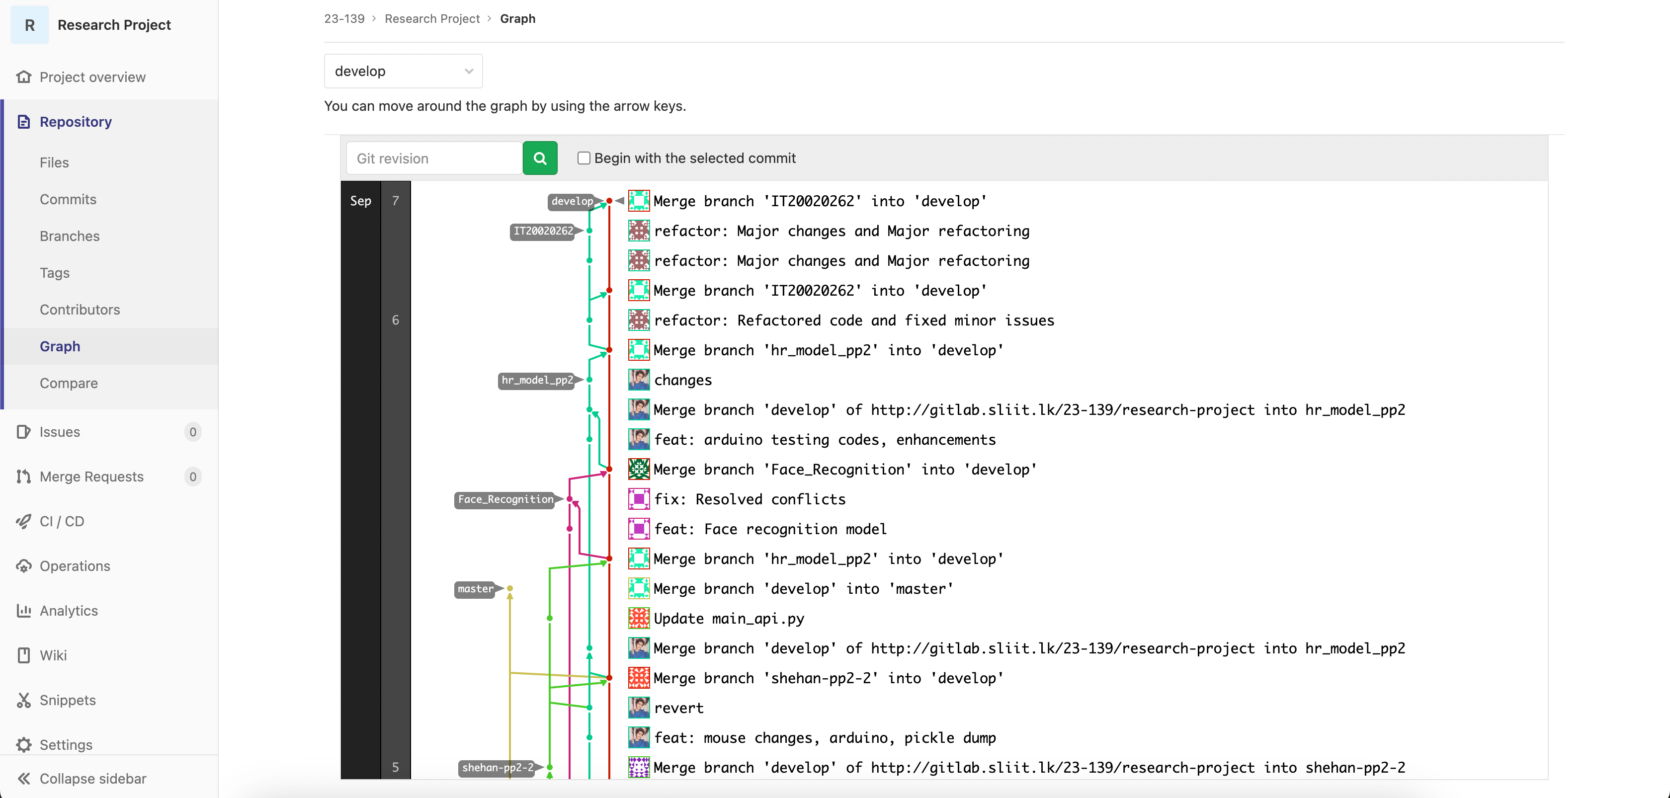

# MEETINGS

## 5.1 MEETINGS WITH THE SUPERVISOR (MR. SAMADHI RATHNAYAKE)

The subsequent details outline the meetings that have taken place with the supervisor, highlighting the collaborative efforts between the team and the supervisor to ensure the project's progress and success.

|  |  |  |
| --- | --- | --- |
| **Date** | **Reason** | **Mode** |
| 08/06/2023 | Discussion regarding the research paper publications | WhatsApp call |
| 23/06/2023 | Discuss about the NBQSA nominations | WhatsApp call |
| 30/07/2023 | Discuss about the current progress of the research | Physical |
| 13/08/2023 | Progress of the research papers | Zoom |
| 18/08/2023 | Met to get the declaration form with the sign filled for the NBQSA competition | Physical |
| 30/08/2023 | Discuss the updates of PP2 and to give guidelines for the presentation | Zoom |
| 03/09/2023 | Discuss any issues before the PP2 viva | Zoom |

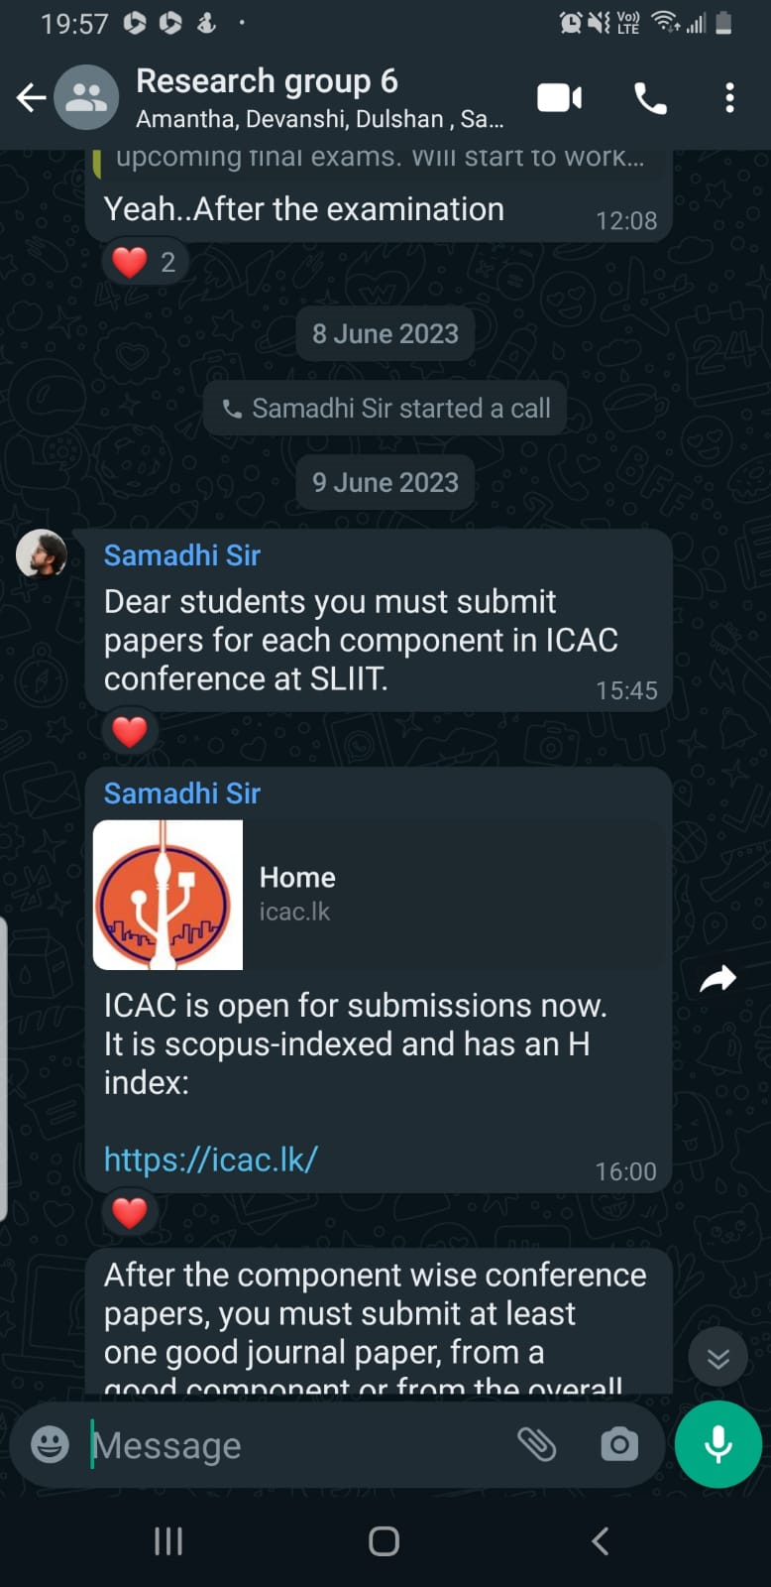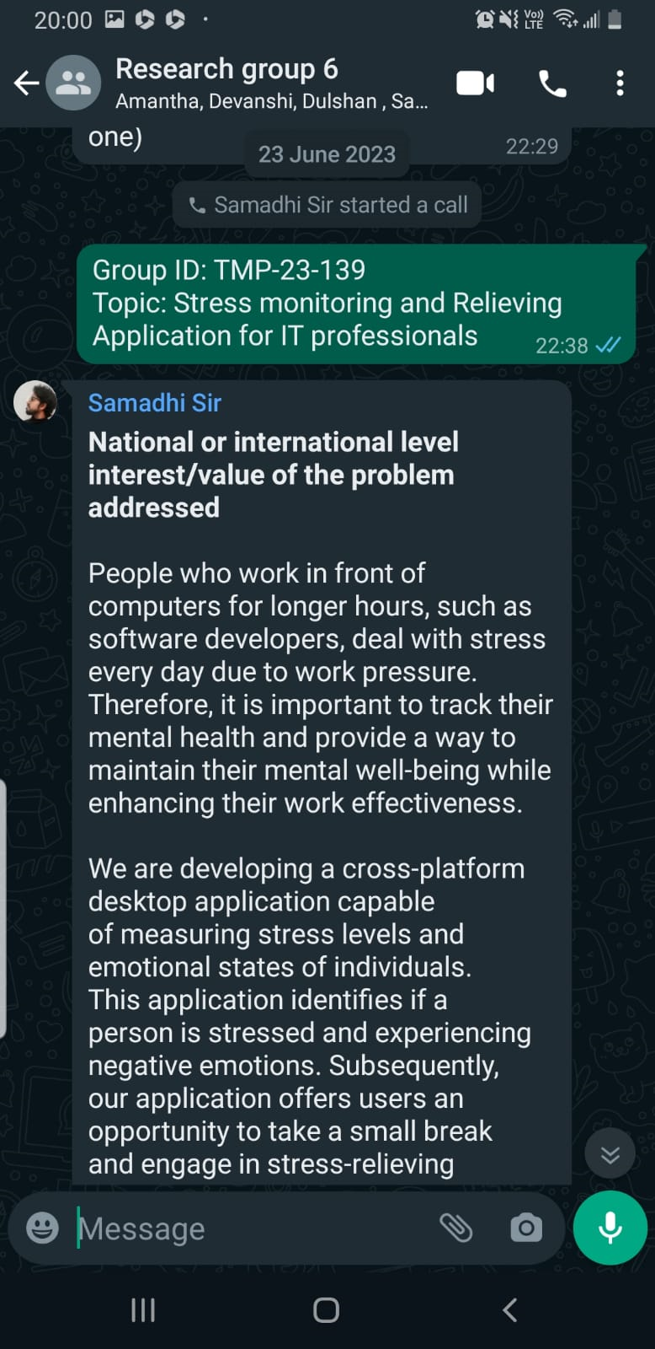

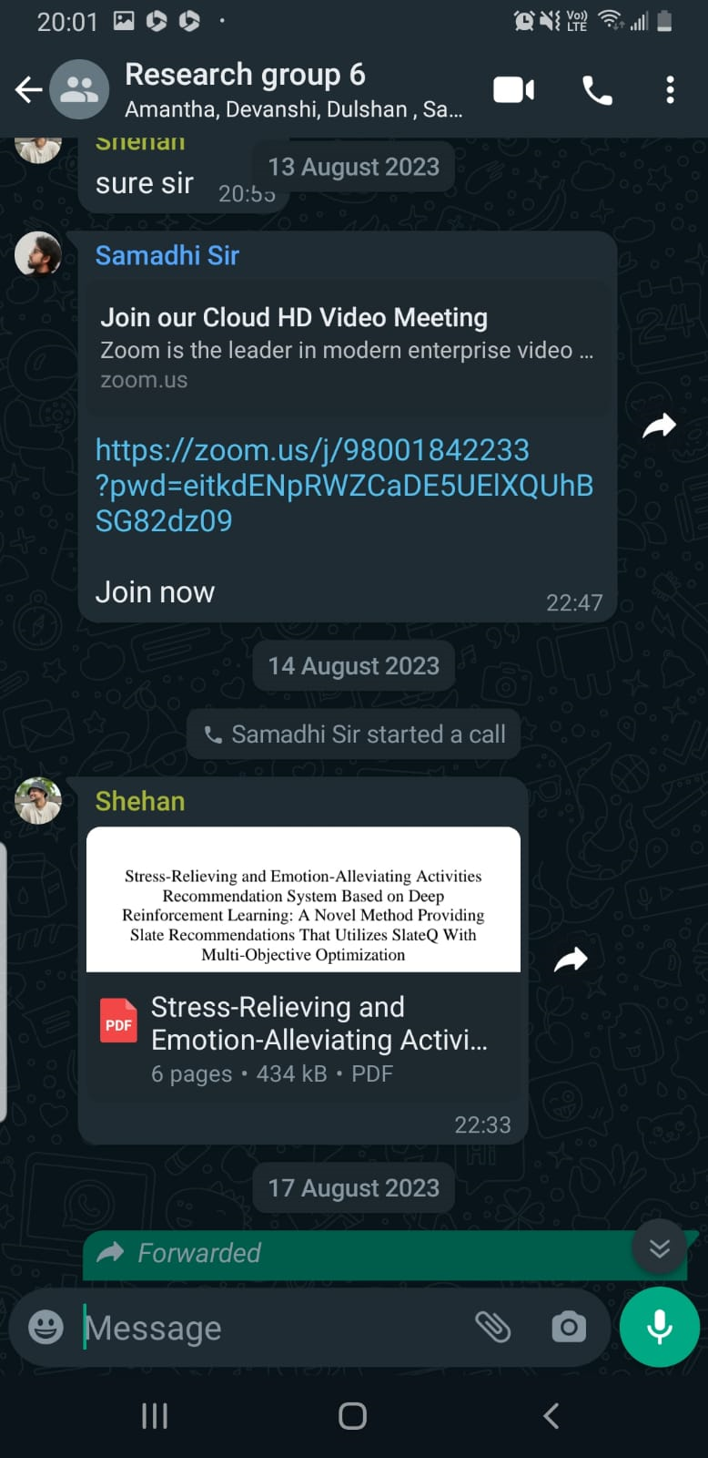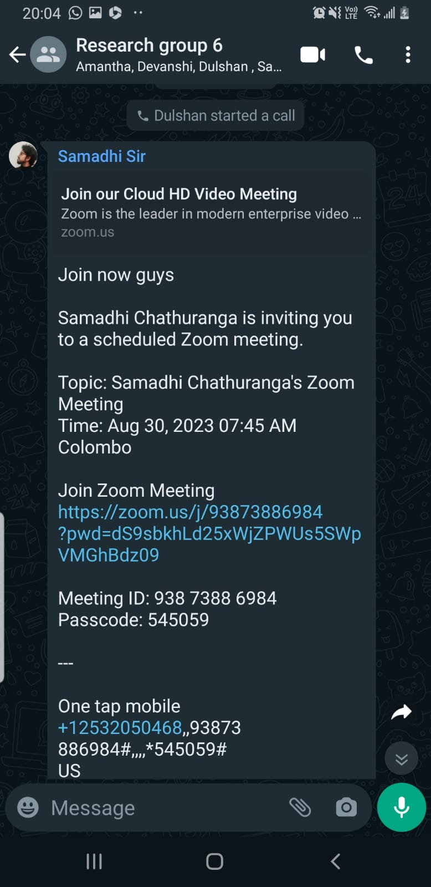

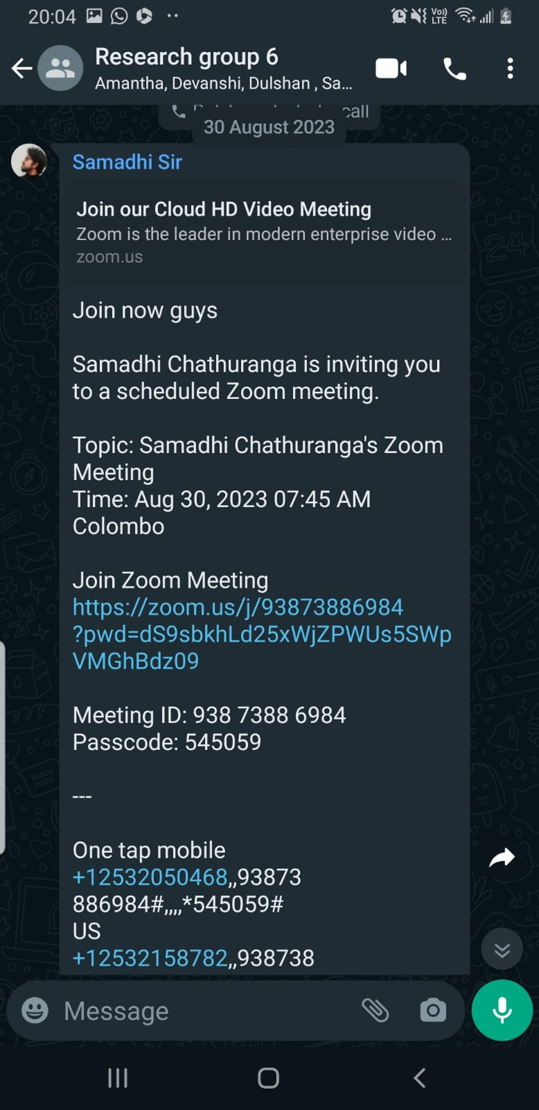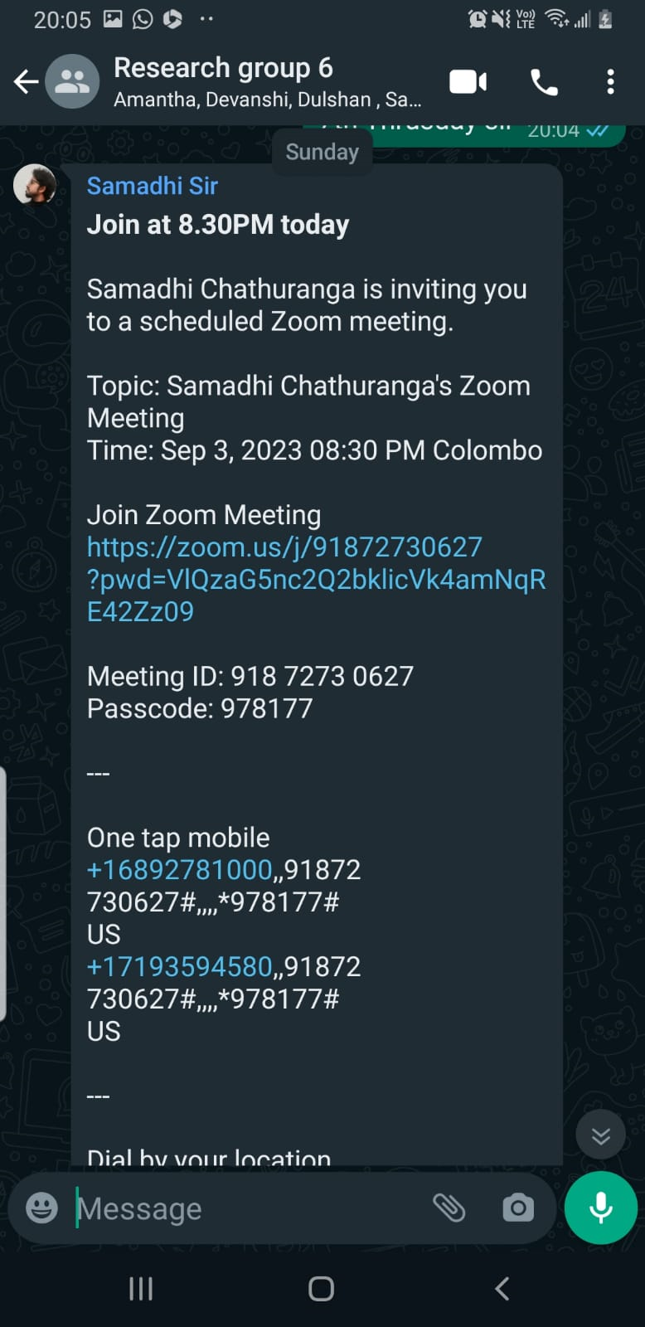

## 5.2 MEETINGS WITH THE CO-SUPERVISOR (MS. DEVANSHI GANEGODA)

Below are the details of the meetings conducted with the co-supervisor, who also guided us with a lot of effort.

|  |  |  |
| --- | --- | --- |
| **Date** | **Reason** | **Mode** |
| 05/08/2023 | Discuss about the current progress of the project | Physical |

## 5.3 MEETINGS WITH THE EXTERNAL SUPERVISOR - PYSCHOLOGIST (MS. AROSHA DASSANAYAKE)

Given that the research project focused on stress monitoring and stress relief, seeking guidance from a psychologist as our external supervisor was crucial. The following meetings were conducted with the external supervisor to enhance the project.

|  |  |  |
| --- | --- | --- |
| **Date** | **Reason** | **Mode** |
| 14/08/2023 | Status of the research was conveyed to the external supervisor | WhatsApp Call |
| 29/08/2023 | Meeting with external supervisor regarding concerns for resolving issues within the psychological domain | Microsoft Teams |

**GOOGLE MEETS Meeting on 15/03/2023**

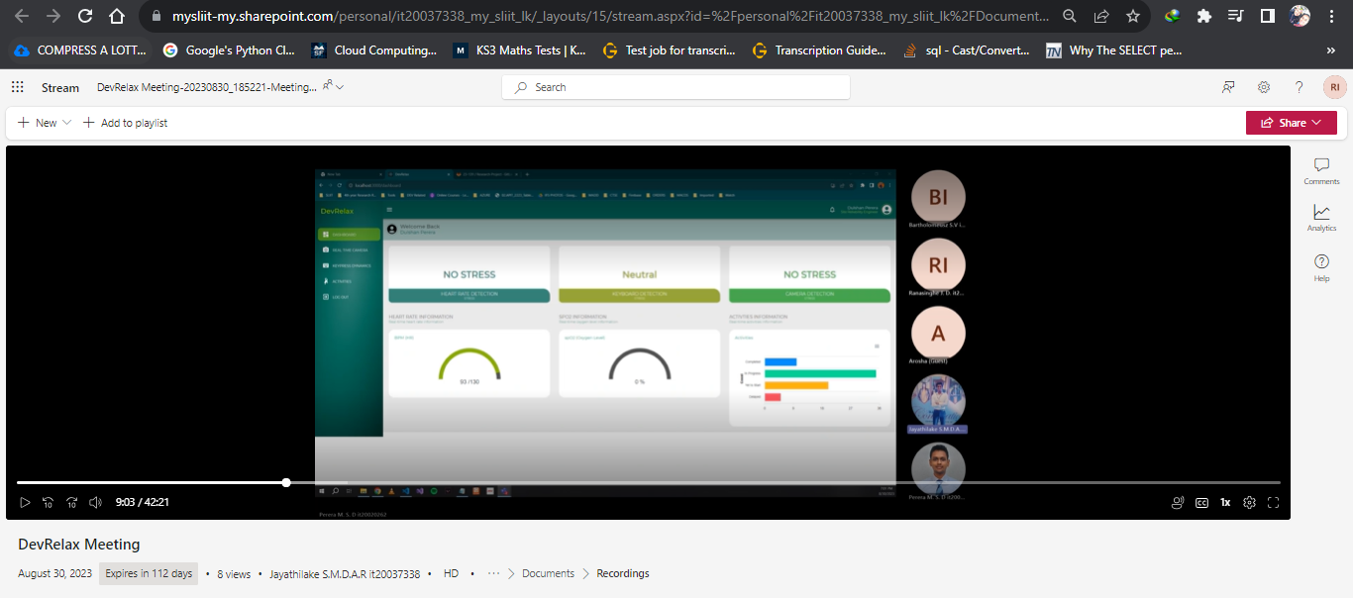

## 5.4 MEETINGS WITH THE EXTERNAL SUPERVISOR – CEO AT XINOTECH (MR. THILANGA JAYARATNE)

To address the commercialization aspect of our product, we sought guidance from an IT organization. The commercialization plan was extensively discussed with them, and we benefited greatly from the feedback and support provided during our discussions. The following highlights the key meetings and interactions held with the IT organization for the advancement of our commercialization strategy.

|  |  |  |
| --- | --- | --- |
| **Date** | **Reason** | **Mode** |
| 19/08/2023 | Discuss about the current progress of the project and the testing phase with the company | Physically |

## 5.5 MEETINGS WITH THE TEAM

Several meetings were held with the team while there was also a scheduled recurring Teams meeting which was held once every week to discuss the progress of the project. Apart from this, WhatsApp calls were used to coordinate small matters while Google Meets was used as the platform to discuss issues in the development phase. Moreover, a WhatsApp group is also maintained by the team to discuss frequent updates regarding the research project.

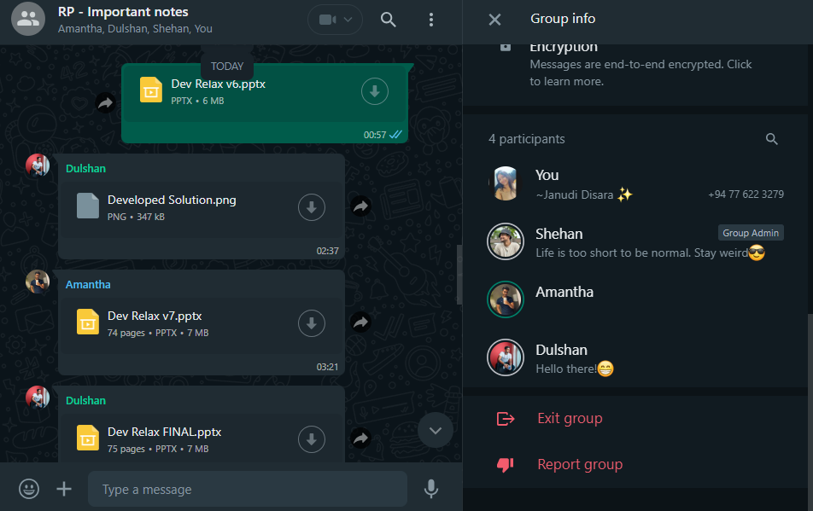

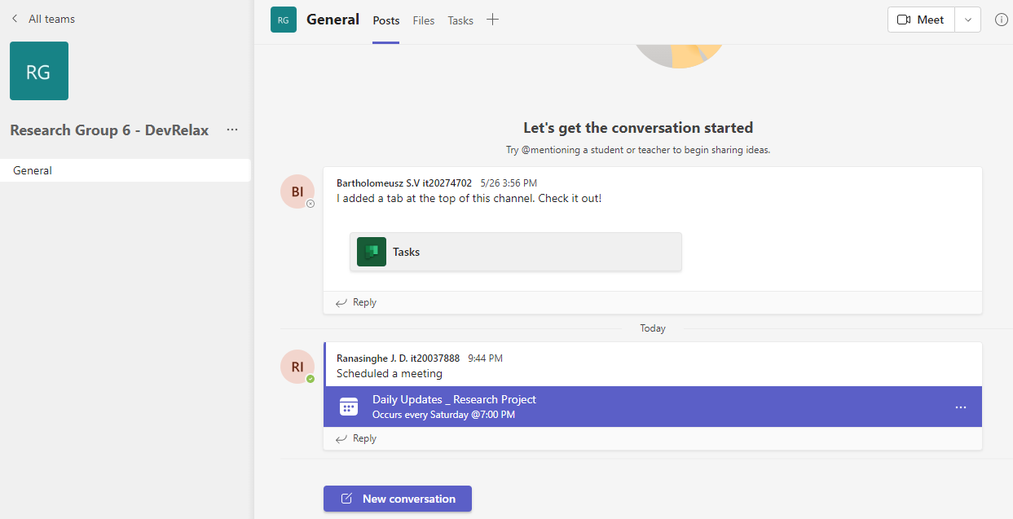

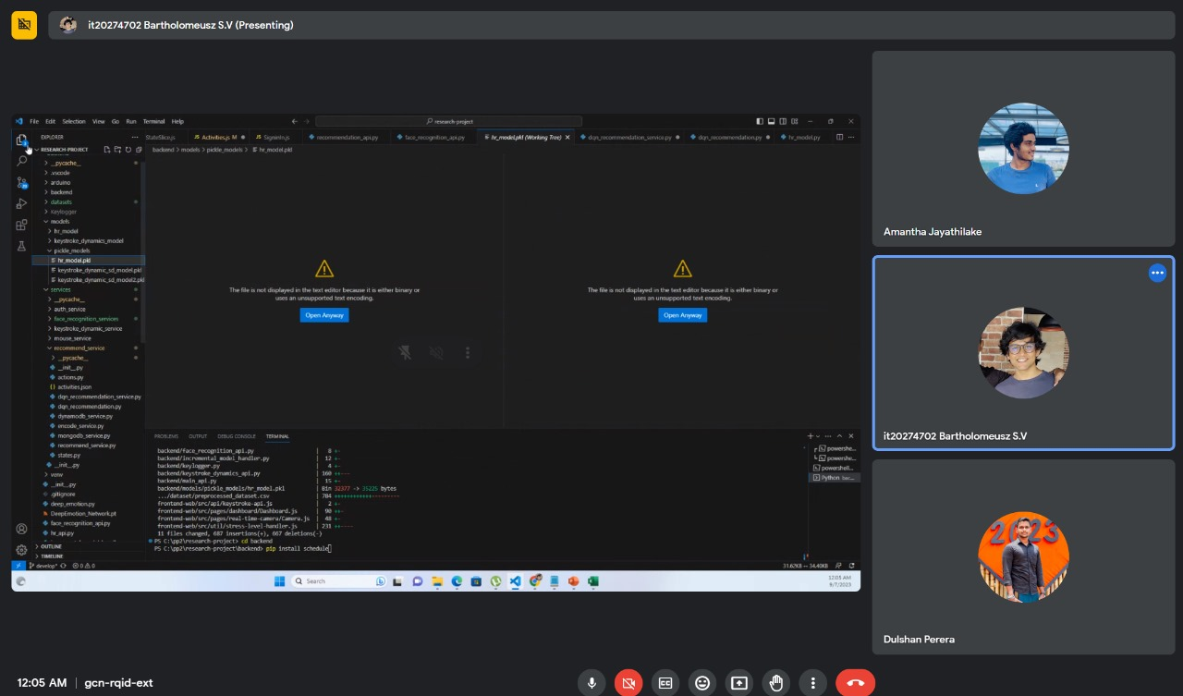

# OTHER ACTIVITIES

## 6.1 NBQSA NATIONAL ICT AWARDS COMPETITION

Our research group was nominated by SLIIT and selected for the NBQSA National ICT Awards competition 2023. We were able to compete in the competition, held at IIT (Informatics Institute of Technology) until the final round successfully.

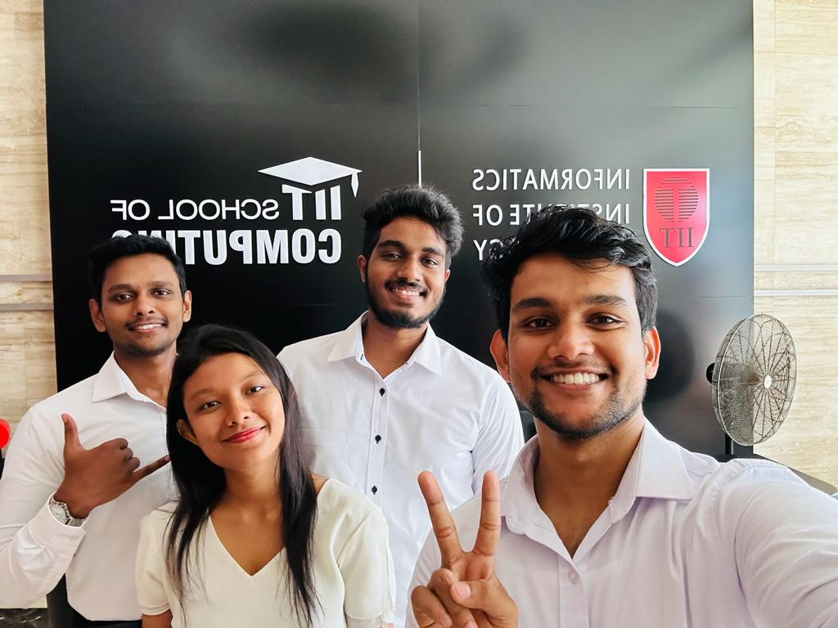

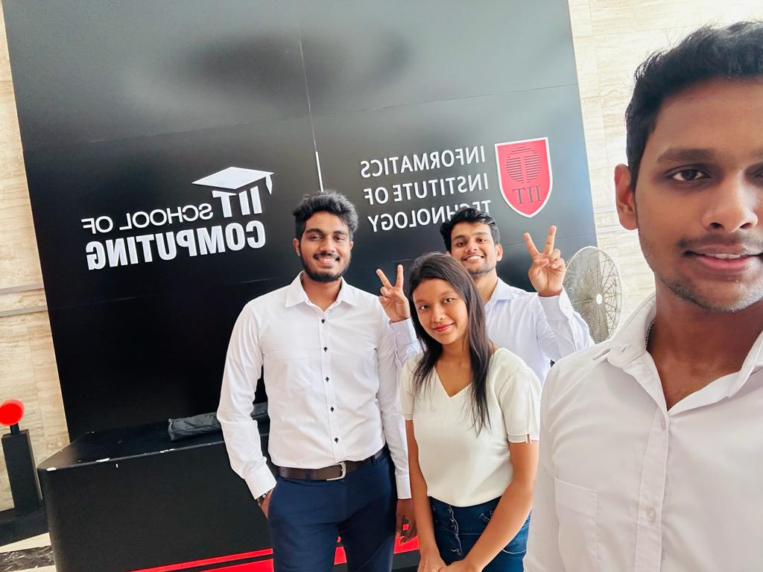

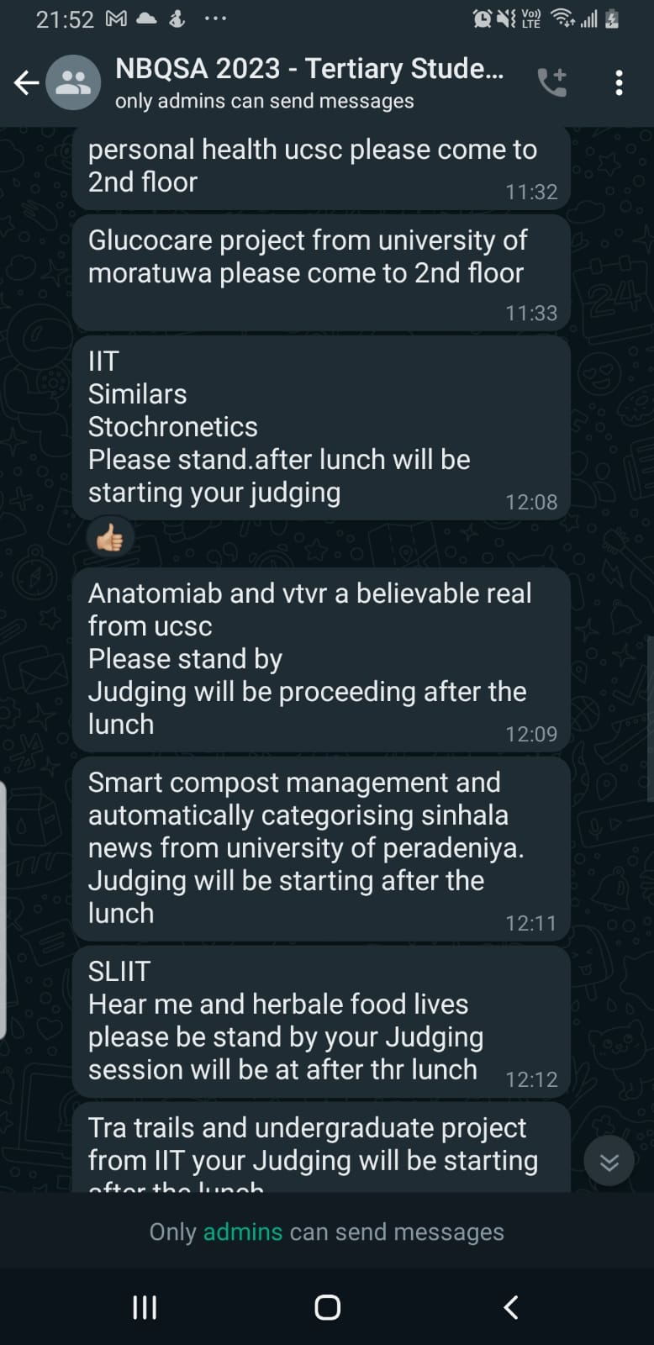

-------------------------------------------- THE END --------------------------------------------